**CD Assignment 5**

------------------------------

Name: Yash Oswal

Div: B Roll no: 38

SRN: 201901226

-------------------------------

### Question:

Design a YACC and corresponding LEX specification to check the syntax of if and if .. else statement of C language.

Consider Assignment statement/s in the body of if and else part. Detect atleast one syntactic error. Upload a single file with input , output and YACC and LEX specification code.

**Input :**

if(a==1) then b=1; else b=5;

**Output :**

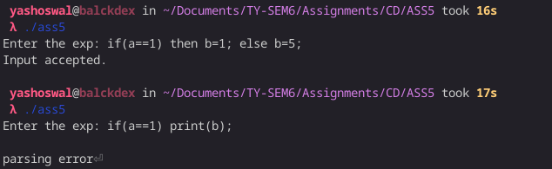

**Code:**

**ass5.l :**

%option noyywrap

%{

#include "y.tab.h"

%}

alpha [A-Za-z]

digit [0-9]

%%

[ \t\n]

if {return IF;}

then {return THEN;}

else {return ELSE;}

{digit}+ return NUM;

{alpha}({alpha}|{digit})* {return ID;}

"<=" {return LE;}

">=" {return GE;}

"==" {return EQ;}

"!=" {return NE;}

"||" {return OR;}

"&&" {return AND;}

. return yytext[0];

%%

**ass5.y:**

%{

#include <stdio.h>

#include <stdlib.h>

void yyerror(char *);

%}

%token ID NUM IF THEN LE GE EQ NE OR AND ELSE

%right '='

%left AND OR

%left '<' '>' LE GE EQ NE

%left '+''-'

%left '*''/'

%right UMINUS

%left '!'

%%

S : ST {printf("Input accepted.\n");exit(0);};

ST : IF '(' E2 ')' THEN ST1';' ELSE ST1';'

| IF '(' E2 ')' THEN ST1';'

;

ST1 : ST

| E

;

E : ID'='E

| E'+'E

| E'-'E

| E'*'E

| E'/'E

| E'<'E

| E'>'E

| E LE E

| E GE E

| E EQ E

| E NE E

| E OR E

| E AND E

| ID

| NUM

;

E2 : E'<'E

| E'>'E

| E LE E

| E GE E

| E EQ E

| E NE E

| E OR E

| E AND E

| ID

| NUM

;

%%

void yyerror(char *s)

{

printf("\nparsing error");

}

int main()

{

printf("Enter the exp: ");

yyparse();

return 0;

}